Cimarron Elementary-Middle School News
May 2022 Edition
SHOUT OUTS!!!!
*Shout out to our teachers who have worked hard to build up our students’ experiences, not only academically within the classroom, but also through experiential learning through field trips, combined days with our fellow district students and colleagues in Eagle Nest, and through Positive Behavior Interventions. We have the best staff!!!

PICTURE ORDER UPDATE
Any orders placed for pictures for a CEMS student should be in by mid May. If you have any questions, please contact Ms. Hamilton at 575-376-2241, extension 318, or email her at shamilton@cimarronschools.org.

LIBRARY REMINDER:
Don't forget! Library books need to be returned. Take a look through your shelves at home and make sure all library books are returned to school. Also, mark your calendars for the summer reading program on Fridays, starting June 10th from 9:30 to 11:30 am.

BAND NEWS
Congrats to the Cimarron HS Wind Ensemble on their first place win in the 1A to 3A category at the NM State Band Contest! The students overcame two encroaching wildfires on Saturday April 23rd to make the trip down to Rio Rancho to perform for three adjudicators and were deemed the best small school band.
The CEMS Band will be participating in a Mini Band Bootcamp on Monday May 9th for their extended learning day. Two guest teachers are coming down to help teach the students in small groups and help them polish their music for the final performance.
The final concert of the year is on May 12th at the CHS Gym, which will feature all band students in the district, 6th to 12th grade in Cimarron and Eagle Nest. We hope to see you there!

NEWS FROM MR. MAR:
5th Science- This class is working on reading and interpreting data from tables, graphs, line plots, pie
charts, and other methods of displaying information.
4th Math- Students are finishing up their geometry unit with finding lines of symmetry.
4th Science- Just completed study of the planets, stars, Milky Way Galaxy, Sun, and constellations.
4th SS- Learning about the state of New Mexico, ie. state aircraft, state insect, state animal, state gem,
etc.
K-4 Students will be attending a field trip to Vermejo Park Ranch on May 18. Stations will be set up and students will rotate through each station.

IMPORTANT MAY DATES
May 11: CHS Academic Awards Ceremony at 5:30 (cafeteria)
May 15: CHS Athletic Awards Ceremony at 2:00 (cafeteria)
May 17: CEMS Academic Awards Ceremony at 5:30 (PAC)
May 18-19: CHS Finals
May 20: CHS Baccalaureate at 6:00 (Cimarron Methodist Church)
May 21: CHS Graduation at 10:00
May 24: CHS Make Up Finals
May 24-25: Cimarron Middle School Finals
May 26: CEMS Field Day
May 26: Last Day; All students dismiss at 1:00

ATHLETICS

Baseball
Our baseball team had a season of rebuilding, growth, and development. They grew with each and every game, and we are looking forward to seeing their successes as a result next year!

Track
Our girls’ track team took 2nd place at districts and the boys’ track team took first place. We have 16 athletes that will be competing at the state track and field championships May 6 and 7. Good luck Running Rams!

ATTENDANCE
Please remember that we do have an attendance policy at CHS and CEMS. Your child's attendance is critical to their learning...if they aren't there to receive their instruction, then it makes it much harder to learn the concepts and complete the assignments. If your child is going to be absent, the parent/guardian must call the school office by 9:00 am on the day of their absence to report it and the reason for the absence so that the secretary can inform teachers and mark their attendance accordingly.

BOX TOPS
See the directions at the end of the newsletter on how to easily and electronically give Box Tops to our school!

Check out the district website, www.cimarronschools.org, for school and district information, the monthly newsletter, and much more! You can also find great things on our “Cimarron Municipal Schools, NM” district facebook page.

If you, or your organization, have any announcements, events, etc. to be included in our monthly newsletters, please email it to jmartinez@cimarronschools.org by the 3rd Friday of the month, in order for it to go out on the next month's newsletter. If you would like a hard copy of our newsletter sent home with your child (or have it mailed to you) instead of receiving it via email or the website, please email Jody Martinez at the email address above.

Box Tops for Education
Please follow the steps below to create a log in to scan your box tops.
- Navigate to the Box Top Link - https://www.boxtops4education.com/
- If you don’t have an account already you will want to select JOIN FREE, if you are downloading this on your phone select the 3 lines ( ) at the top of the page.
- Next it will prompt you to Find Your School, so simply enter 87714 as the zip code and select Next

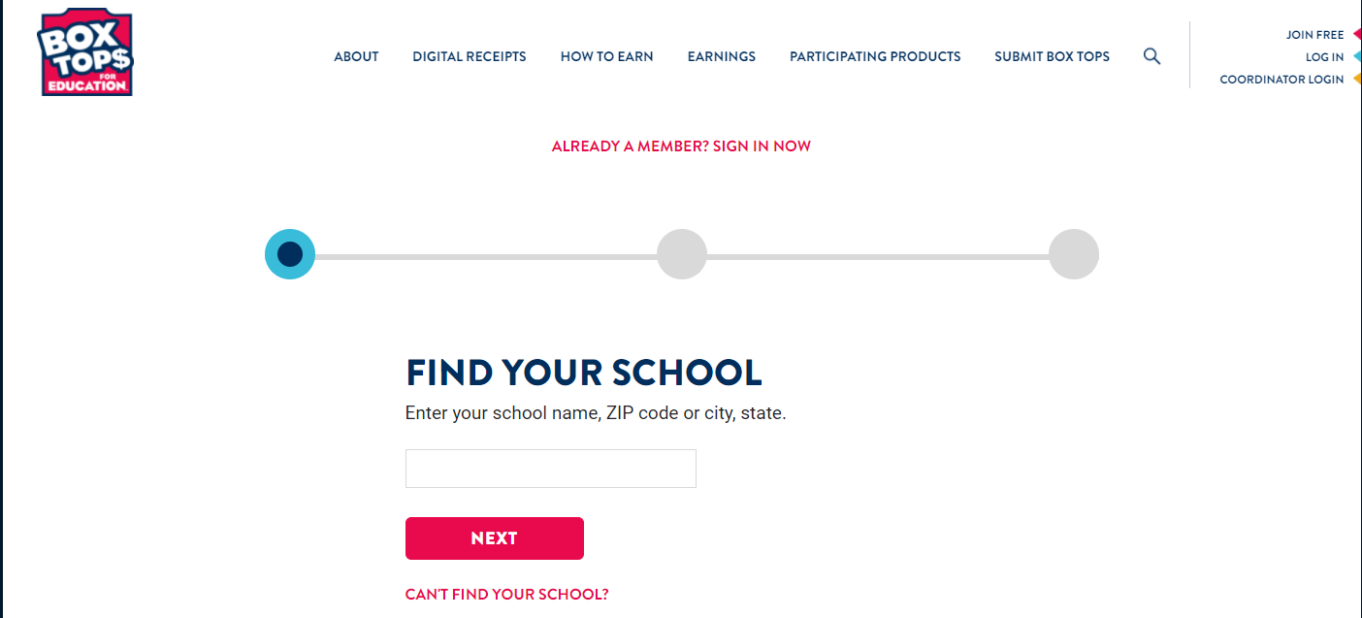

- After you enter your zip code it will give you an option on which school you would like to collect Box Tops for. Click on the Select This School under EN or CEMS to select the school you wish to support.
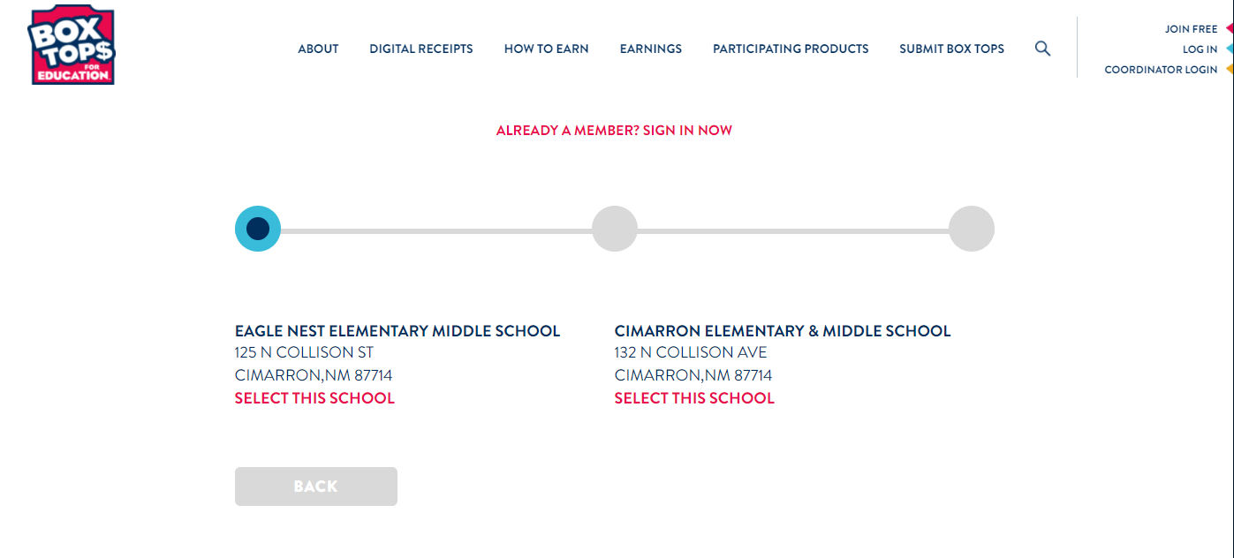
- The next steps will prompt you to enter information about yourself. Please continue until you have completed all steps.
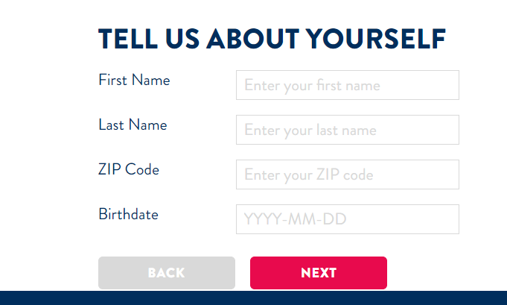
- Once you have completed your registration you will be able to start scanning your receipts. Please note that your receipts will expire after a certain amount of time.

